Fast Fourier Transform
Exercise 1
x1 = [0 2 4 6];
x2 = [1 3 5 7];
N = 8;

k = (0:N/2-1);
WNk = exp(-1j * 2 * pi * k / N);

G1 = fft(x1);
G2 = fft(x2);

X = [G1 + WNk .* G2, G1 - WNk .* G2];

disp('FFT Result:');
disp(X);

X_matlab = fft([0 1 2 3 4 5 6 7]);
disp('MATLAB FFT Result:');
disp(X_matlab);

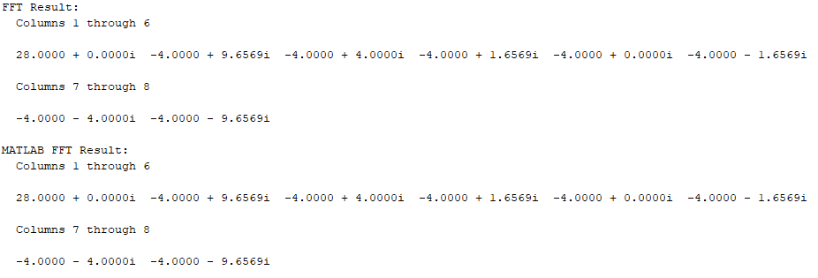
Exercise 2
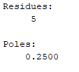
function y = fft_2pt(x)
if length(x) ~= 2
error('Input must be of length 2');
end
y = [1 1; 1 -1] * x(:);
end

Z-Transform
Exercise 1
num = [5];
den = [1, -1/4];
zplane(num, den);
[r, p, c] = residue(num, den);
disp('Residues:');
disp(r);
disp('Poles:');
disp(p);

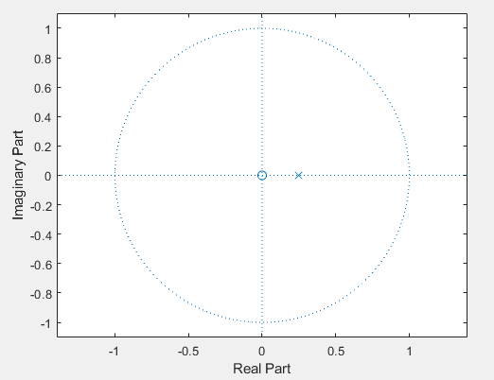

Exercise 2
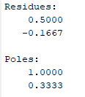
num = [1,0];
den = [3,-4,1];
[r, p, c] = residue(num, den);

disp('Residues:');
disp(r);
disp('Poles:');
disp(p);

Exercise 3
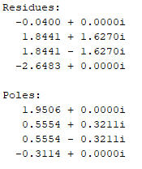
1)
num = [1 -1 -4 4];
den = [1 -11/4 13/8 0 -1/4];

[r, p, c] = residue(num, den);
disp('Residues:');
disp(r);
disp('Poles:');
disp(p);

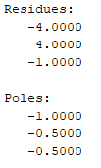
2)
num = [0 0 1 0];
den = [1 2 1.25 0.25];

[r, p, c] = residue(num, den);
disp('Residues:');
disp(r);
disp('Poles:');
disp(p);

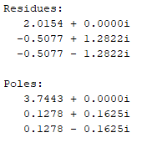
3)
num = [1 -3 4 1];
den = [1 -4 1 -0.16];

[r, p, c] = residue(num, den);
disp('Residues:');
disp(r);
disp('Poles:');
disp(p);

